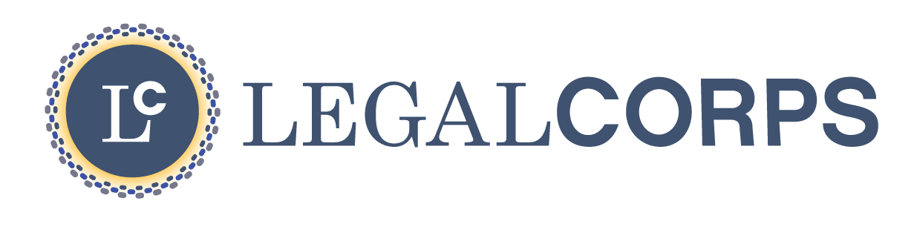

BUSINESS ASSISTANCE RESOURCES
for inventors and Small Businesses
IOWA

Greater Des Moines Partnership provides service to businesses in the 7 county area. A resource hub was created specifically with small businesses in mind, providing online tools, small business and startup blogs and podcasts, education and networking events, and so much more. Dsmpartnership.com/growing-business-here/business-resources.
Drake Papajohn Center for Entrepreneurship serves to create a strong relationship between Drake University and the entrepreneurial community in Greater Des Moines through programs and events‌. drake.edu/cbpa/centers/pappajohn/
Iowa Economic Development provides more resources for small businesses. Iowaeda.com
Iowa Center for Economic Success is committed to empowering people to strengthen and stabilize their financial futures through business ownership and investment. theiowacenter.org
Iowa SourceLink is the premier online resource connecting entrepreneurs and small businesses to more than 360 resource providers across Iowa. iasourcelink.com
NewBoCo fosters a diverse and inclusive community, supporting, and encouraging people with big ideas of any kind. Newbo.co
VentureNet Iowa connects ideas to resources, management, and investors, to create jobs and build businesses in Iowa. venturenetiowa.com

